John Rene Lorelli

DataScience Foundations

W8

M8 Box Plots

Create a report with the following:

\* I did not include xlab= “” or ylab= “” in the code because the default labeling from Rstudio was clear and it would have been what I was going to put manually anyways.

1. The entire R code used when creating the box plot in (1).
   1. head(iris)
   2. boxplot(Sepal.Length ~ Species, data=iris, main="3 Species Sepal Length")
2. Screenshot of the box plot created in (1).

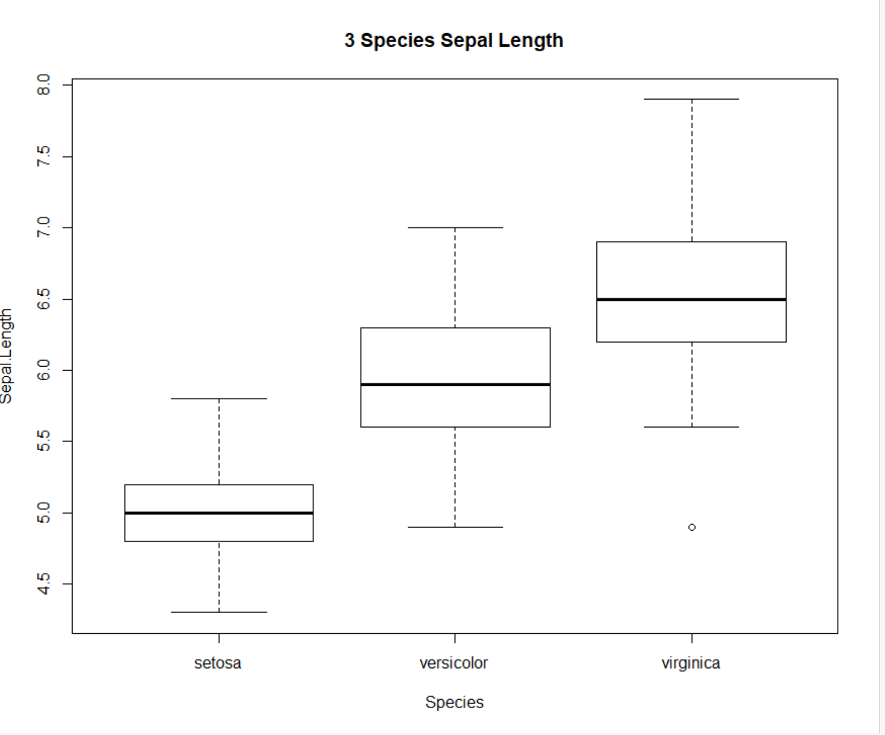

1. The entire R code used when creating the box plot in (2).
   1. boxplot(Sepal.Width ~ Species, data=iris, main="3 Species Sepal Width")
2. Screenshot of the box plot created in (2).
3. 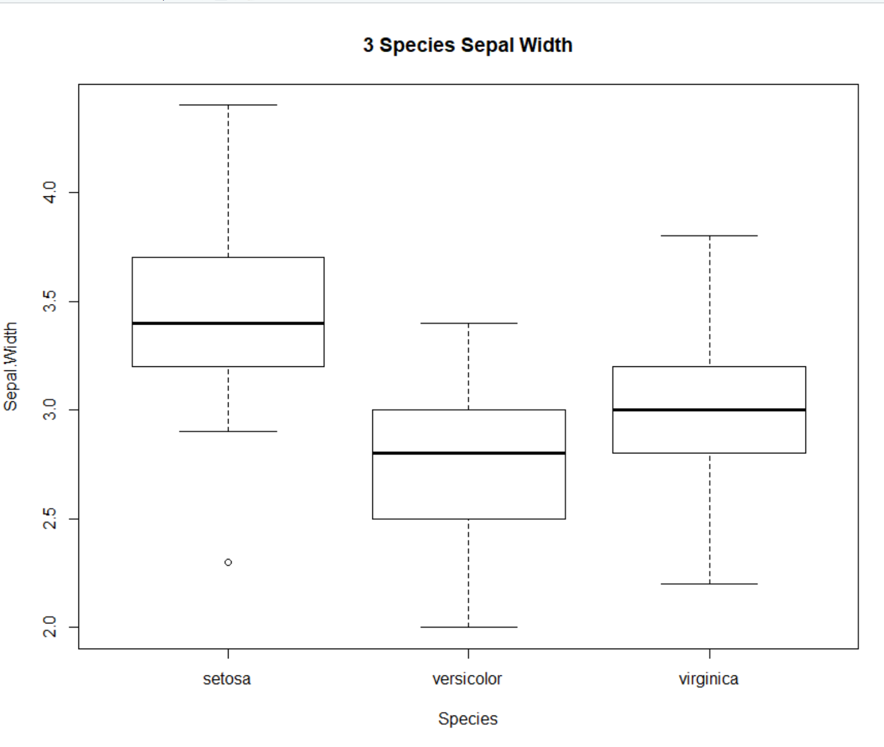
4. The entire R code used when creating the box plot in (3).
   1. boxplot(Petal.Length ~ Species, data=iris, main="3 Species Petal Length")
5. Screenshot of the box plot created in (3).
6. 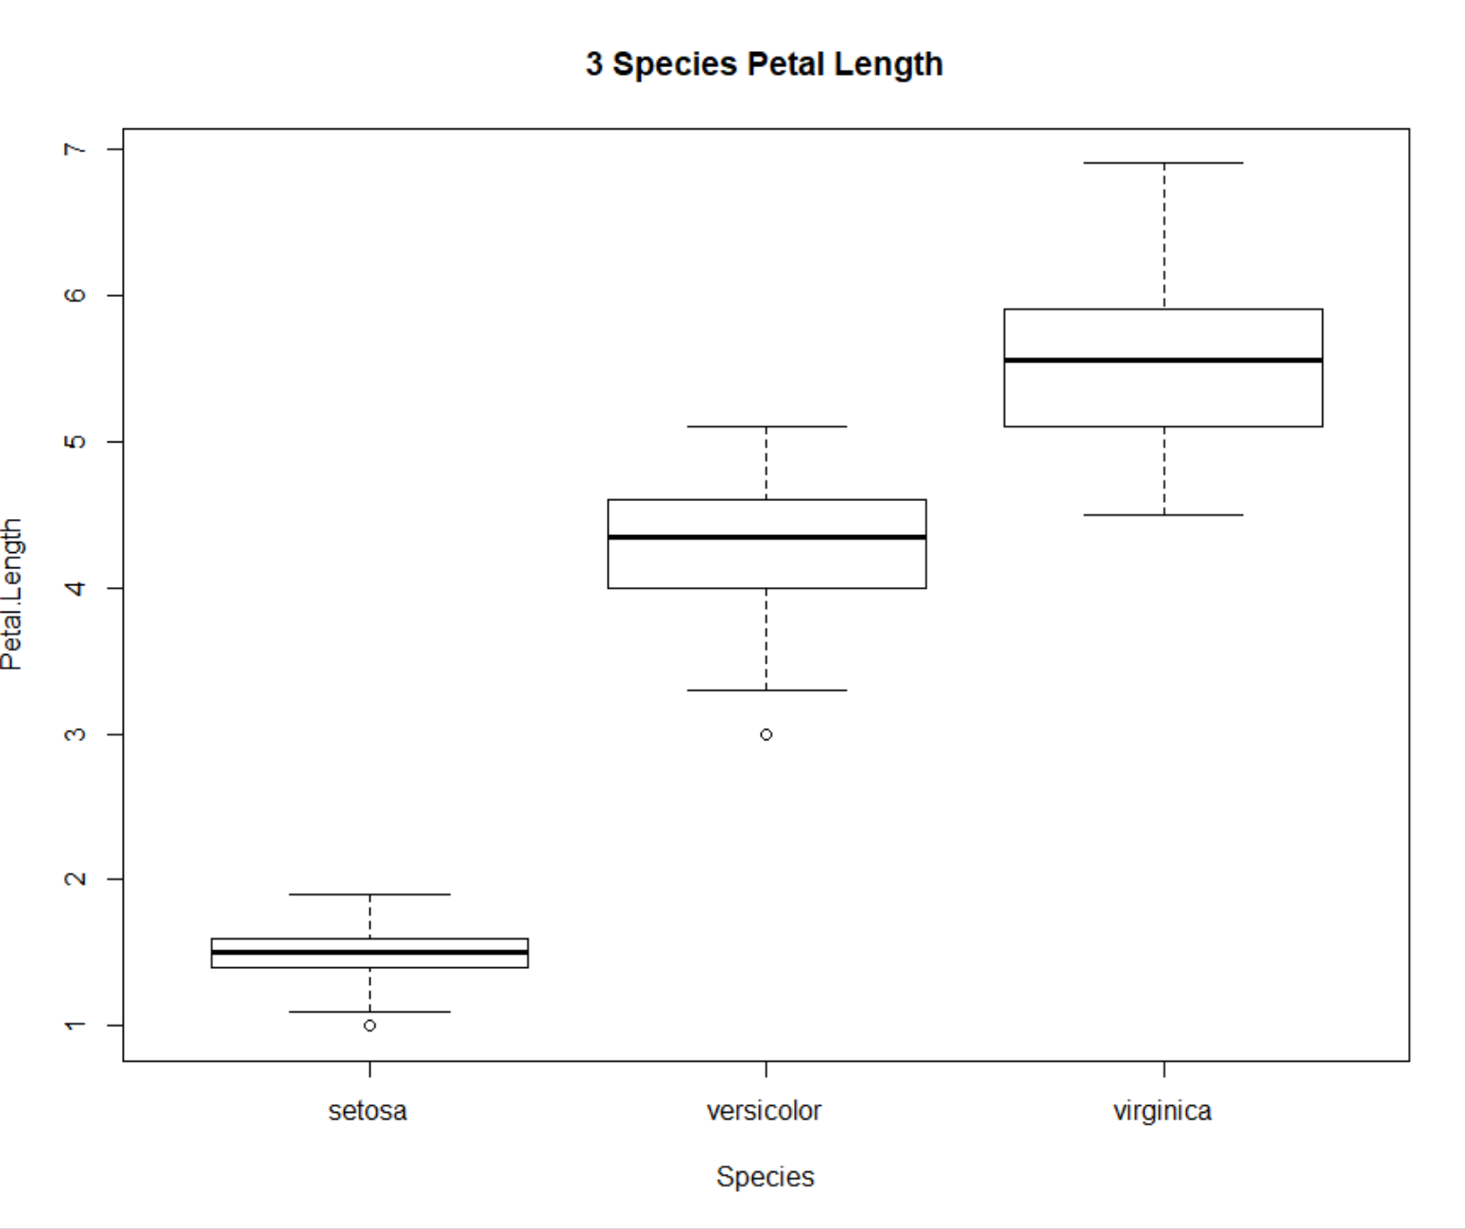
7. The entire R code used when creating the box plot in (4).
   1. boxplot(Petal.Width ~ Species, data=iris, main="3 Species Petal Width")
8. Screenshot of the box plot created in (4).

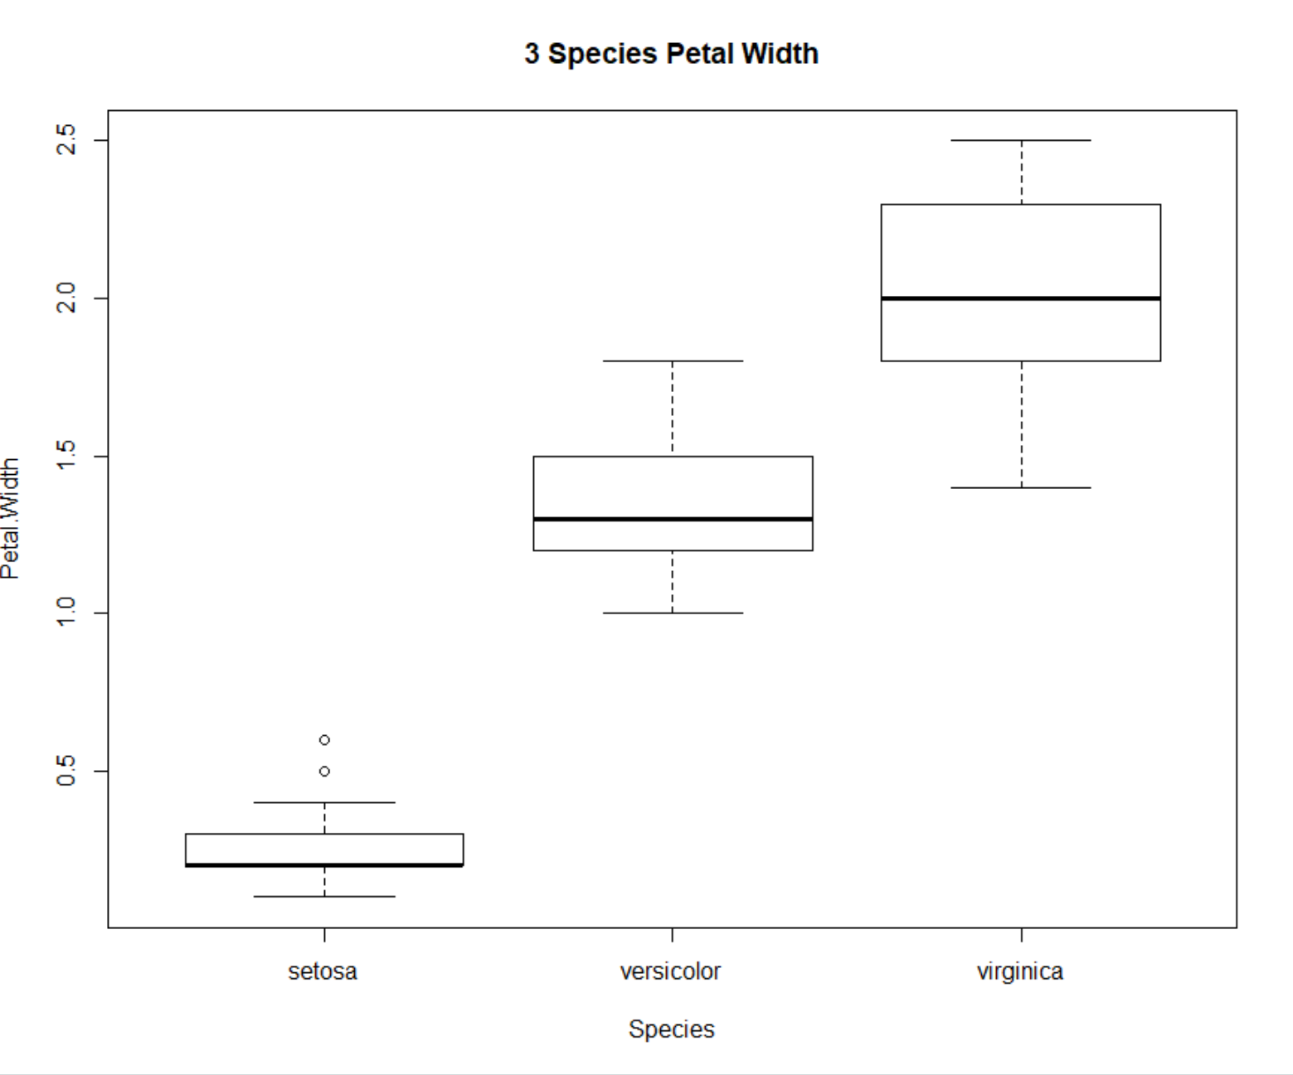

1. How you would identify the species a certain sample of an iris flower would belong to, based on these plots.

Virginica seems to be the biggest overall all except for sepal width. Setosa seems to be smallest with the exception of the sepal width. Versicolor is overall in the average of both the other species.